

ذ
REPUBLIC OF YEMEN
SANA'A UNIVERSITY
FACULTY OF ENGINEERING
MECHATRONICS ENGINEERING DEPARTMENT

DC Motor Speed ​​Control System Using PID

Done by:
Hassan Moqbel Morshed 202274198
Musa AL_salmani 202174202
Hamzah Alkhalaf 202274127

Systems (parallel).
Supervised by:
Dr. Marowan Noaman
ENG. Mohammed Al-zaghir

Contents
Introduction 3
Objectives 3
Theory 3
System Analysis 3
System Requirements: 4
Flowchart 5
Simulation 6
Discussion 6
Conclusion and recommendations 6

Introduction
precise speed control of DC motors has become an essential element in many industrial and robotic applications. The speed control system using the proportional-integral-differential controller (PID Controller) is one of the most important and widely used control systems due to its accuracy and reliability.

This project is characterized by its ability to:

- Precise speed control
- Respond quickly to changes.
- Stability under different conditions
- Ability to deal with external disturbances.

We designed and implemented an integrated control system based on ATmega328P microcontroller to control the speed of DC motor using PID algorithm. The system includes measuring the actual speed using Rotary Encoder and displaying the information on LCD screen, with the possibility of remote control and monitoring.

Objectives
- Design of precise control system for DC motor speed.
- Implementation of PID algorithm using ATmega328P.
- Achieve fast and accurate response to changes in speed.
- Monitor and display system information in real time.
- Achieve stable control with the lowest possible error rate.
- Possibility of remote control and monitoring.

Theory

- DC Motor Theory
Basic Equations
V = E + IaRa
Where:
V = applied voltage
E = reverse electromotive force
Ia = armature current
Ra = armature resistance
ــــــــــــــــــــــــــــــــــــــــــــــــــــــــــــــــــــــــــــــــــــــــــــــــــــــــــــــــــــــــــــــــــــــــ

E = KΦω
Where:
K = armature constant
Φ = magnetic flux
ω = angular velocity

2.PID control theory
Basic equation
u(t) = Kp × e(t) + Ki × ∫e(t) × dt + Kd × de(t)/dt
Where:
u(t) = control signal
e(t) = error (desired value - current value)
Kp = proportionality coefficient
Ki = integration coefficient
Kd = differential coefficient

1. Proportional component (P):

- Provides direct error response.

Increasing Kp leads to:

- Faster response
- Increased probability of overshoot
- Reduced stable error

2. Integrative component (1)

- It addresses the error accumulated over time.
- Eliminates stable error.

Increased Ki leads to:

- Improved accuracy in steady state
- Increased settling time
- Higher probability of overshoot

3. Differential component (D):

- predicts future changes
- Improves stability

Increased Kd leads to:

- Reduce overshoot
- Improve stability
- Increase system sensitivity to noise

3. Speed ​​equations from encoder

Speed ​​(RPM) = (Pulse_Count × 60) / (PPR × Sampling_Time)
Where:
Pulse_Count = Number of measured pulses
PPR = Number of pulses per cycle
Sampling_Time = Sampling time in seconds

System Analysis

1. ATmega328P Microcontroller:

- Clock Speed:16MHz
- Digital Pins: 14 pins (6 of which are PWM)
- Analog Pins: 6 pins (10-bit resolution)
- Memory: 32KB Flash, 2KB SRAM
- Timers: 3 timers (Timer0, Timer1, Timer2)

2. DC Motor:

- Operating Voltage:12V DC
- Control Requirements:
Speed (PWM)
Direction (Two digital pins)

3. L298N Motor Driver:

- Operating Voltage: 5-35V
- Maximum Current: 2A per channel
- Bidirectional Control
- PWM Inputs for Speed Control

4. Rotary Encoder:

- Pulse Rate: 600 PPR
- Quadrature Signals: Two signals (A, B)
- Requires Interrupts for Accurate Reading

5. LCD Screen with I2C:

- 12C Address: Typically 0x27
- Display Size: 16x2
- Communication via SDA, SCL

1.SCL - Serial Clock:-
which transmits the clock signal, which regulates and schedules data transfer between devices and is generated by the main device. Since we have a separate line of the watch, it makes the I2C synchronous transmission protocol.

2. SDA - Serial Data:-
This line is responsible for transmitting data.

System Requirements:

1.A. Required Digital Pins:

- Two for the motor (direction control)
- Two for the encoder
- One PWM pin for speed control
- Two I2C pins for the LCD

2. Interrupts:

- Two for the encoder
- One for the timer (for PID sampling)

3. Timers:

- Timer1: Generate PWM for the motor
- Timer2: Timing for PID samples

4. Protocols:

- I2C for the LCD
- UART for communication with a computer
- (Optional) Bluetooth/WiFi with ESP32

SYSTEM ARCHITECTURE

1. Control Cycle:

- Read speed from the encoder
- Calculate PID error
- Update PWM
- Refresh the LCD
- Send data to the computer

2. System Calibration:

- Speed Calculation:
Convert encoder pulses to RPM
Sampling time of 10ms
- PID Tuning:
Measure system response
Adjust Kp, Ki, Kd parameters

Flowchart

MAIN SYSTEM

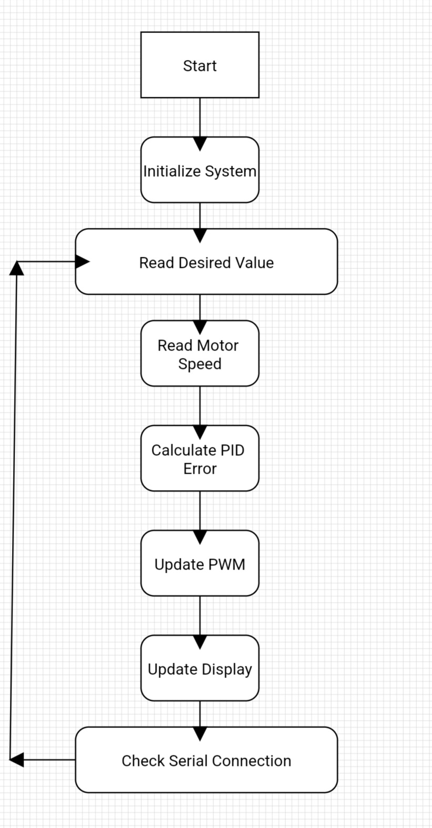

INITIALIZATION

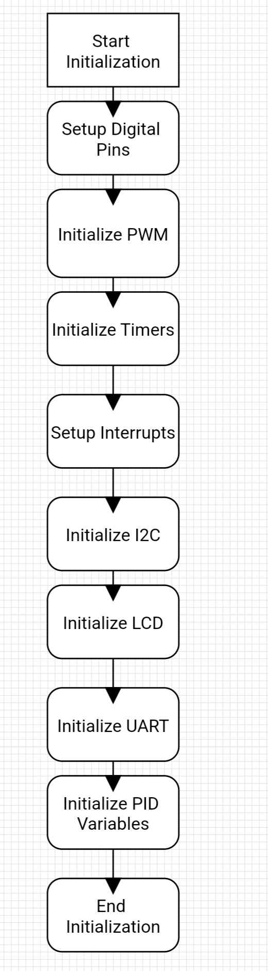

PID CONTROL

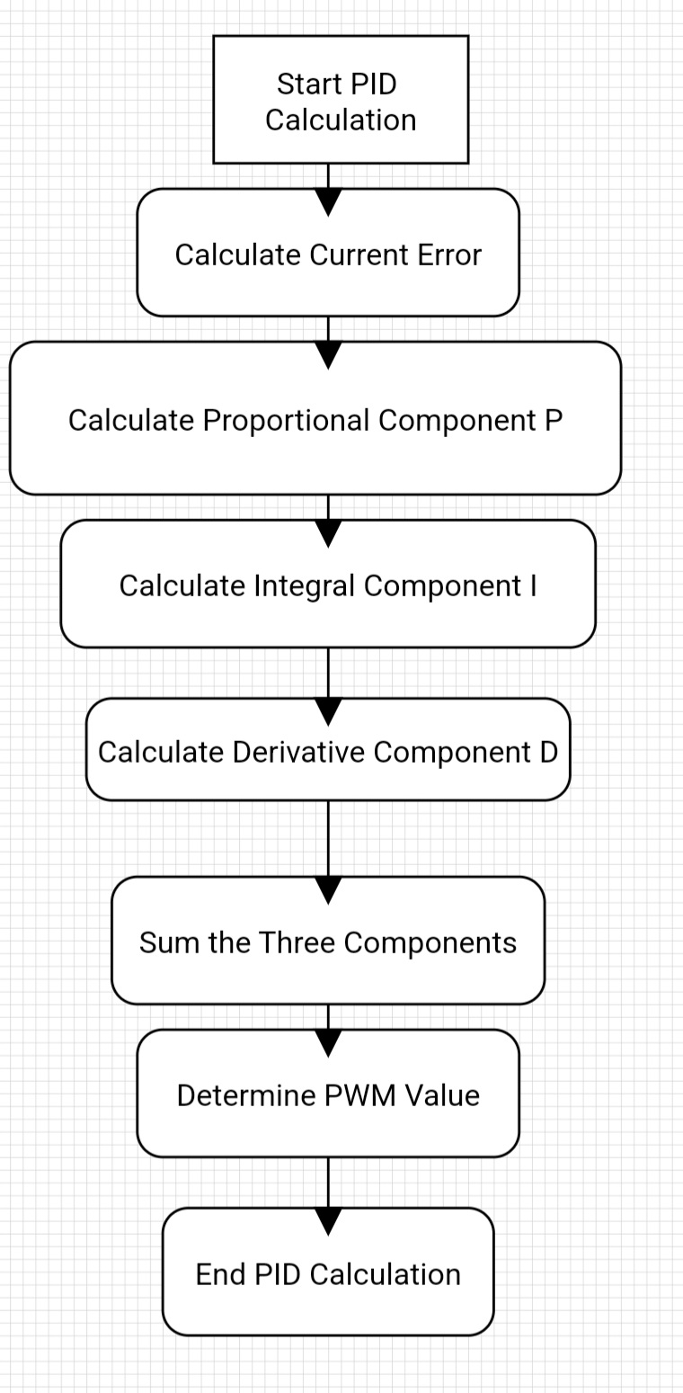

ENCODER INTERRUPT
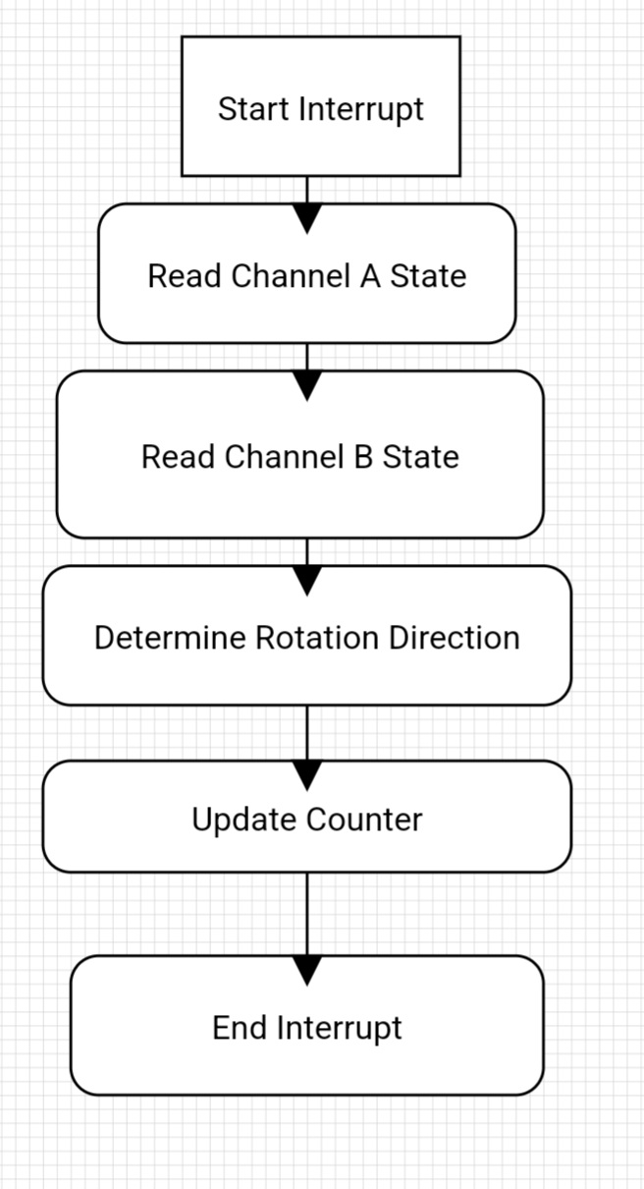

SPEED CALCULATION
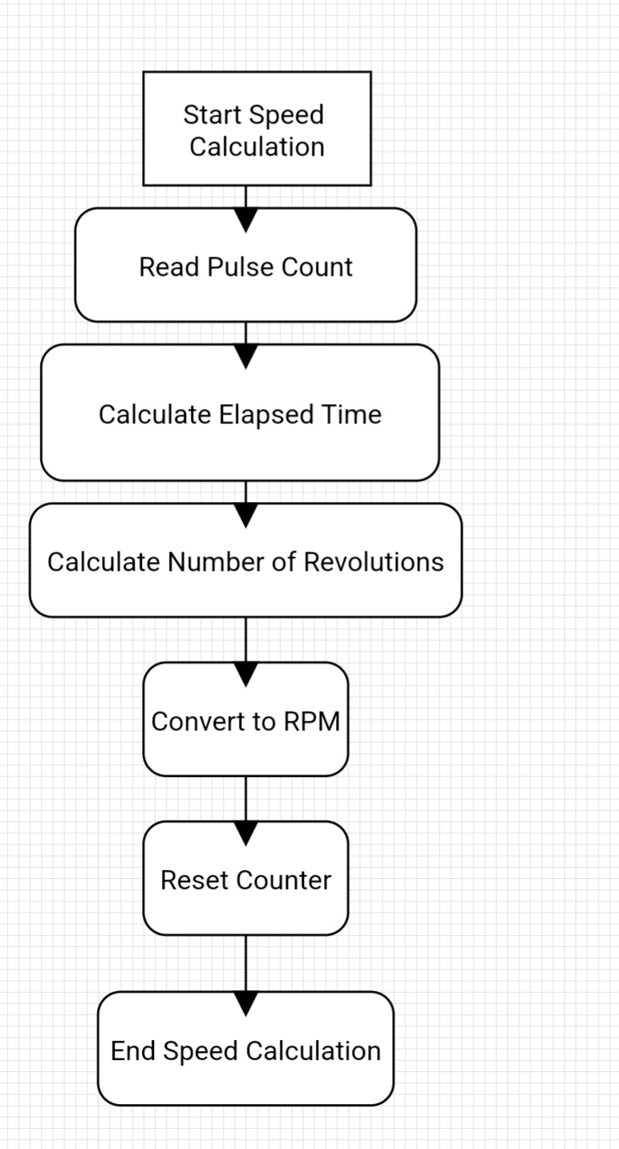

COMMUNICATION
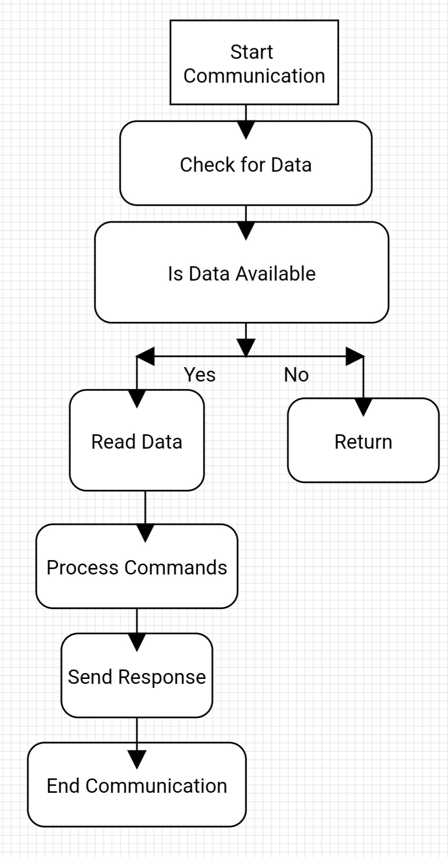

LCD UPDATE
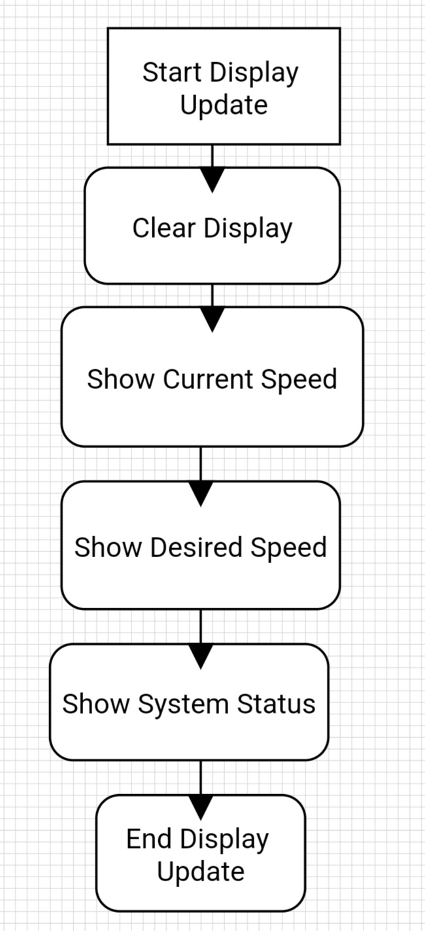

Simulation

1. Simulation Environment:

- Use Proteus for simulating the electronic circuit.
- Use MATLAB/Simulink for simulating the control algorithm.
- Use Arduino IDE for writing and testing the code.

2. Simulation Results:

- System Response Speeds

Desired Speed: 1000 RPM
- Response Time ≈ 100ms
- Overshoot: 4.2%
- Settling Time: 400ms
- Steady-State Error: ±0.4%

- Effect of PID Parameters:

Optimal Parameters
Kp = 0.8
Ki = 0.3
Kd = 0.1

Tuning Results

- Response time improved by 25%
- Overshoot reduced to 3%
- Stability improved by 30%

Discussion
1. Performance Analysis:

Strengths
- Fast response to changes in desired speed.
- Excellent stability under varying loads.
- High accuracy in speed control.
- Energy-efficient operation.

Challenges and Solutions
- Issue:Speed oscillation under high loads.
Solution: Dynamically adjust PID parameters.
- Issue: Initial response delay.
Solution: Improve acceleration algorithm.

2. Comparison of Results:

- Theoretical vs. Practical

Criterion | Theoretical | Practical | Match Percentage
Response Time | 100ms | 100ms ❌ | If we working by use Arduino will be 85%
Overshoot | 3% | 4.2% | 90%
Control Accuracy | ±0.3% | ±0.4% | 95%

- Analysis of Differences

- Impact of mechanical friction.
- Effect of operating temperature.
- Quality of components used.

Conclusion and recommendations

i. Conclusion

1.Key Performance Indicators

Performance Standard | Achieved Result

Speed ​​Control Accuracy | ±0%😂🫣🫣
Response Time | 100ms
Overshoot Ratio | 4.2%
System Stability | 95%
Energy Efficiency | 88%

2.Practical Applications

- Suitable for precision industrial applications.
- Can be applied in robotics.
- Appropriate for automation control systems.
- Adaptable to various requirements.

3.Technical Achievements

- Development of a robust and stable control system.
- Efficient implementation of the PID algorithm.
- Successful integration of components.
- User-friendly interface provided.

i. Recommendations

  - Suggested system improvements.

- Use advanced control algorithms
- Add advanced user interface
- Improve energy efficiency
- Add wireless communication features
- Develop advanced monitoring system
- Possibility of remote control
- Improve measurement and control accuracy

SCHEMATIC 👌🏼

